# [**TVLine Items: Law & Order Special, Most Wanted Promotion and More**](https://tvline.com/2020/10/28/law-order-before-they-were-stars-special-nbc/)

By [Vlada Gelman](https://tvline.com/author/vlada-gelman/) / October 28 2020, 2:17 PM PDT

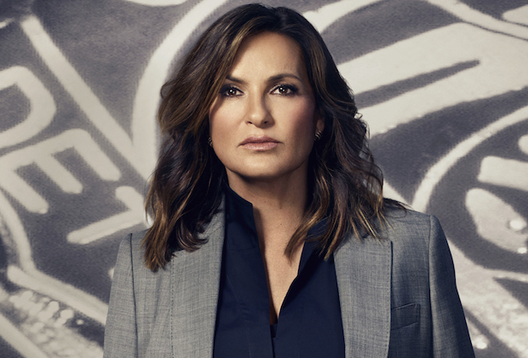

Courtesy of NBC

* [**9**](https://tvline.com/2020/10/28/law-order-before-they-were-stars-special-nbc/#comments)

NBC has set a celeb-studded *Law & Order* special: *The Paley Center Presents Law & Order: Before They Were Stars* will air Thursday, Nov. 12 at 10/9c, following *SVU*‘s Season 22 premiere at 9 pm.

The program will feature interviews with actors who’ve appeared on the franchise as guest stars prior to getting their big break. Participants include *This Is Us*‘ Ron Cephas Jones, Chris Sullivan and Susan Kelechi Watson, *Hamilton*‘s Leslie Odom Jr., *The Sopranos*‘ Michael Imperioli and Aida Turturro, *Modern Family*‘s Ariel Winter, *Scream Queen*‘s Abigail Breslin, *Chicago Med*‘s S. Epatha Merkerson, *The Vampire Diaries*‘ Paul Wesley and *Agents of S.H.I.E.L.D.*‘s Clark Gregg.

9.2K

'Cobra Kai' Season 5 Finale | Ralph Macchio on THAT 'Karate Kid' Throwback

**Ready for more of today’s newsy nuggets? Well…**

* *FBI: Most Wanted* has promoted YaYa Gosselin, who plays Jess LaCroix’s daughter Tali, to series regular for Season 2, our sister site [Deadline](https://deadline.com/2020/10/fbi-most-wanted-yaya-gosselin-promoted-series-regular-season-2-cbs-1234602730/) reports.

* *Charmed* has tapped Jason Diaz (aka *The 100*‘s Levitt) to recur during Season 3 as Antonio, a charming classmate of Maggie’s who becomes her nemesis, per [Deadline](https://deadline.com/2020/10/jason-diaz-charmed-david-desantos-roswell-new-mexico-the-cw-1234604826/).

* HBO Max and Cartoon Network have greenlit *Unicorn: Warriors Eternal*, a supernatural animated series helmed by Emmy-winning creator Genndy Tartakovsky (*Samurai Jack*, *Dexter’s Laboratory*). It follows a team of ancient heroes who prematurely reawaken in the bodies of teenagers, with their memories lost and their powers fragmented.

* FX on Hulu’s *Y: The Last Man* adaptation has added Ashley Romans (*Shameless*) and Olivia Thirlby (*Goliath*) to its cast as it begins production in Toronto; the series is slated to debut next year.

* The Shudder anthology series *Creepshow* has added the following actors to its Season 2 cast: Marilyn Manson (*Sons of Anarchy*), Ali Larter (*The Rookie, Heroes*), Iman Benson (#*BlackAF*), Ryan Kwanten (*True Blood*), Barbara Crampton (*Re-Animator*), C. Thomas Howell (*Criminal Minds, Southland*), Denise Crosby (*Star Trek: The Next Generation*), Breckin Meyer (*Robot Chicken*), Ted Raimi (*The Evil Dead*), Kevin Dillon (*Entourage*) and Eric Edelstein (*We Bare Bears*).

* truTV has ordered the cooking competition series *Fast Foodies*, in which *Top Chef* winners Kristen Kish and Jeremy Ford, plus *Iron Chef* champ Justin Sutherland, invite a celebrity guest “to bring their favorite fast food item to the restaurant as they compete to perfectly recreate and then skillfully reimagine the dish.” Celebrity guests include Joel McHale (*Community*), James Van Der Beek (*Don’t Trust the B—- in Apartment 23*), Andy Richter (*Conan*), Amanda Seales (*Insecure*) and Bobby Lee (*Splitting Up Together*), among others.

* CBS will air *Play On: Celebrating the Power of Music to Make Change* on Saturday, Dec. 5 at 9/8c. Hosted by Kevin Bacon and Eve, and benefitting the NAACP Legal Defense and Educational Fund, Inc. and WhyHunger, the concert special will feature an eclectic assortment of music stars appearing from the Troubadour in Los Angeles, the Apollo Theater in New York City and the Bluebird Cafe in Nashville.

**Which of today’s TVLine Items pique your interest?**